**FINAL PROJECT REPORT**

***Date:*** 31st August, 2016

***Name:***

|  |
| --- |
| Heather Parker |

***Project Title:***

|  |
| --- |
| Superoxide dismutase and infection with *Mycobacterium tuberculosis* |

**Please copy the "Specific Objective(s)" statement, entered on your application form, in the space below.**

**Objective:** Our aim is to determine whether *Mtb* SODA is a virulence factor that protects the bacteria against killing by human neutrophils, and whether SODA released from *Mtb* will allow MPO to oxidize isoniazid and thereby lower its toxicity.

**Briefly describe how successful you were in achieving the stated objective(s). If the objective(s) was not achieved, explain why that is the case and describe what you did manage to achieve.**

Neutrophils are an important component of the innate immune system. They phagocytose pathogenic bacteria into organelles called phagosomes. Neutrophils can kill bacteria in the phagosome through oxidative mechanisms by the production of bactericidal reactive oxygen species or, they may use a range of proteins and proteases which comprise the non-oxidative arm of neutrophil bactericidal activity. Oxidative killing is mediated by the action of an enzyme complex (NADPH oxidase) present in the phagosomal membrane that generates superoxide. Superoxide and downstream derivatives, such as hypochlorite (HOCl - bleach) generated by the enzyme myeloperoxidase (MPO), mediate oxidative killing of bacteria in the phagosome. Superoxide dismutase (SOD) is an enzyme that removes superoxide and has the potential to interfere with phagosomal killing. The original aim of this project was to assess whether a superoxide dismutase, SODA, produced in large amounts by *Mycobacterium tuberculosis* protects this bacterium from neutrophil killing by reducing the oxidative stress that the bacteria are exposed to when ingested into the phagosome. This was initially to be studied by examining neutrophil killing of a non-pathogenic but related Mycobacterium, *Mycobacterium smegmatis*, and comparing this to killing of an *M. smegmatis* strain overexpressing SODA from *M. tuberculosis*. Our project aim was dependent on the ability of neutrophils to kill *Mycobacterium smegmatis* by oxidative mechanisms. At the time of writing there were no reports in the literature on how neutrophils killed this bacterium. During this study we found that neutrophil killing of *M.smegmatis* was not dependent on oxidants, as the bacteria were killed as effectively when the oxidative killing process was inhibited (Figure 1). Results of these experiments indicate that *M. smegmatis* are either killed non-oxidatively or when oxidative killing is prevented other non-oxidative mechanisms can be as efficiently utilized. We generated a strain of *M. smegmatis* that overexpresses the *M. tuberculosis* SODA. We found that the presence of SODA did not confer resistance of *M. smegmatis* to neutrophil killing, supporting our finding that oxidative mechanisms are not required for killing of this bacterium (Figure 2).



**Figure 1. Killing of *M. smegmatis* by neutrophils does not require oxidants.** Bacteria were incubated with neutrophils for 90 min in the presence or absence of an inhibitor of the NADPH oxidase (DPI) or inhibitors of myeloperoxidase (TX1 and Azide). Data shows the number of colony forming units (CFU) obtained as a percent of control bacteria incubated for the same length of time without neutrophils. Data represent mean ±SE of three independent experiments with neutrophils from different donors.



**Figure 2. Overexpression of SODA does not protect *M. smegmatis* from neutrophil killing.** Neutrophil killing of (A) *M. smegmatis* and (B) a strain overexpressing SODA from *M. tuberculosis* was assessed by colony forming unit assay. Data shows the number of colony forming units obtained as a percent of control bacteria incubated for the same length of time without neutrophils. Data represent mean ±SE of three independent experiments with neutrophils from different donors.

The highly bactericidal oxidant HOCl generated in the neutrophil phagosome is capable of killing most bacteria. We confirmed that *M. smegmatis* are susceptible to killing by this reactive oxygen species (Figure 3). It was observed that *M. smegmatis* may be more resistant to HOCl-mediated killing than the common human pathogen *Staphylococcus aureus*. This is potentially a very interesting finding and is currently being further investigated. We also examined bacterial survival in the presence of the MPO/Cl-/H2O2 system in a cell-free assay. This system is present within neutrophil phagosomes where, in the presence of chloride, the enzyme myeloperoxidase converts H2O2 (hydrogen peroxide) to HOCl. *M. smegmatis* were also killed by the MPO/Cl-/H2O2 system (Figure 3B).

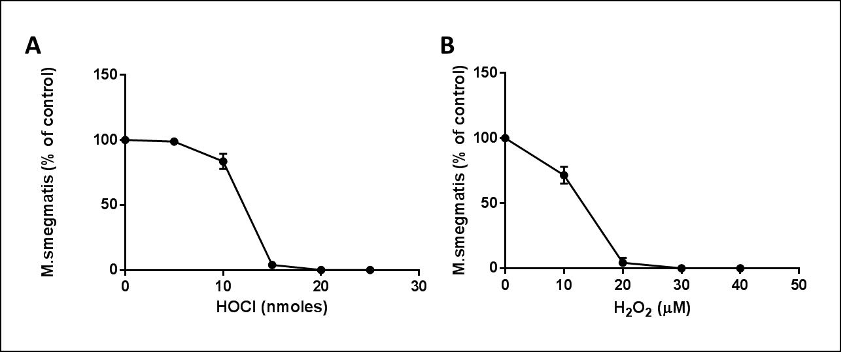

**Figure 3. *M. smegmatis* are killed by HOCl and the HOCl-producing MPO/Cl-/H2O2 system.** Bacteria were incubated with (A) varying concentrations of HOCl for 15 min, or (B) MPO and H2O2 in the presence of chloride for 30 min. Excess HOCl and H2O2 were scavenged by the addition of methionine and catalase, respectively. Samples were then diluted, plated and incubated for 3 days then colonies counted. Data show the number of colony forming units obtained as a percent of control bacteria incubated for the same length of time without HOCl for (A) or MPO and H2O2 for (B). Data represent mean ±range of two independent experiments for (A) and mean ±SE of three separate experiments for (B).

To confirm that neutrophils produce oxidants in the phagosome after ingestion of *M. smegmatis*, we assessed oxidant production by incubating neutrophils with *M. smegmatis* in the presence of the oxidant sensitive probes dihydrorhodamine and dihydroethidium. Fluorescence of both these probes increased when the neutrophils were incubated with *M. smegmatis* compared to neutrophils incubated for the same length of time without bacteria (Figure 4A & B). This increase was due to stimulation of the neutrophil oxidant production system as inhibition of the NADPH oxidase with DPI abrogated the fluorescence increase. Using a fluorescent probe specific for HOCl production we observed that neutrophils produce HOCl in response to *M. smegmatis* and that production of HOCl is abolished when the NADPH oxidase is inhibited (Figure 5).

Our initial objective was also to look at whether SODA released from *M. tuberculosis* will allow MPO to oxidize isoniazid and thereby lower its toxicity. This work was not completed due to time constraints. We hope to do this work with the aid of a summer student and a BBioMedSci hons student next year.

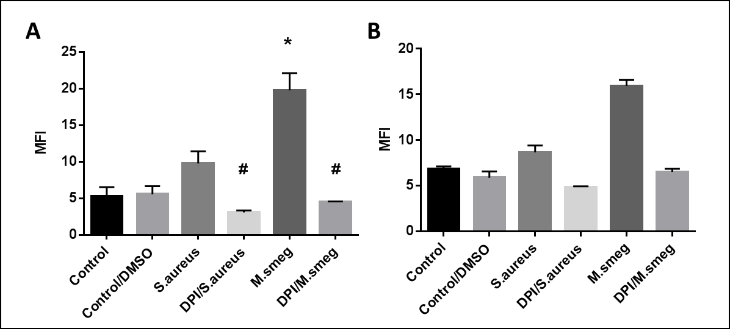

**Figure 4. *M. smegmatis* induces oxidant production within neutrophils.** Neutrophils were incubated with *M. smegmatis* (MOI 1) or *Staphylococcus aureus* (positive control) (MOI 1) for 30 min in the presence of the oxidant-sensitive probes (A) dihydrorhodamine or (B) dihydroethidium. Fluorescence was measured by flow cytometry. Inhibition of the neutrophil NADPH oxidase with DPI abolished the bacterial-induced fluorescence increase. Data represent mean ±SE of four individual experiments with neutrophils from different donors for (A) and the mean ±SD of replicates within a single experiment for (B).



**Figure 5. *M. smegmatis* induces HOCl production within neutrophils.** Neutrophils were incubated with *M. smegmatis* (MOI 1) or *S. aureus* (MOI 10) (positive control) for 30 min in the presence of the HOCl-specific probe R19S. Fluorescence was measured by flow cytometry. Inhibition of the neutrophil NADPH oxidase with DPI abolished the bacterial-induced fluorescence increase. Data represent mean ±range of two independent experiments with neutrophils from different donors.

**Briefly describe any interesting outcomes which might not have been considered in your original objectives (if any).**

There were several interesting unexpected outcomes to this project. Firstly, we found that neutrophils can kill *M. smegmatis* equally well without the use of oxidants as when they are present. Secondly, our preliminary data suggests *M. smegmatis* are more resistant to HOCl than other bacteria such as *S. aureus*. This is a very interesting finding and we intend to continue investigating this. We hope to write the data generated during this project and our further findings regarding sensitivity of *M. smegmatis* to HOCl into a publication in the near future.